CS 405G Project Final Report

Sarah Vessels and Tom McKnight



Table of Contents
Overview 4
Statement of Problem 4
Distribution of Work 4
Database Design 4
Entity-Relation Diagram 4
Diagram 5
Discussion 6
People Entity 6
Credit_Card Entity and Owns Relation 6
Price Attribute of Order_Item Relation 6
Cart 6
Tables and Fields 6
Orders Table 6
Diagram 7
Column Descriptions 7
Functional Dependencies 7
Order_Items Table 7
Diagram 7
Column Descriptions 7
Functional Dependencies 7
People Table 8
Diagram 8
Column Descriptions 8
Functional Dependencies 8
Books Table 8
Diagram 8
Column Descriptions 9
Functional Dependencies 9
Toys Table 9
Diagram 9
Column Descriptions 9
Functional Dependencies 9
Credit_Cards Table 9
Diagram 10
Column Descriptions 10
Functional Dependencies 10
Normal Form of the Database 10
First Normal Form 10
Definition 10
Discussion 10
Second Normal Form 11
Definition 11
Discussion 11
Third Normal Form 11
Definition 11
Discussion 11
Programming 12
Database Interface 12
Diagram 12
Database Table Classes 12
ClassName.new( args={} ) 13
ClassName.find( primary_key ) 13
ClassName.create( args={} ) 13
ClassName.delete( primary_key ) 13
InstanceName.update( args={} ) 13
Security Concerns 13
SQL Injection 13
Password Encryption 13
Overview 13
Salt Generation 14
Password Encryption and SQL Injection 14
Relevant Files 14
Primary Files 14
Auxiliary Files 14
Testing 15
Web Interface 15

Overview

Statement of Problem
The task at hand is the implementation of an online e-commerce database system for a fictional company named the Nile Company. The company sells two different types of items – books and toys.

Customers using the system should be able to create an account, view items, place them in a shopping cart, and place their order. Staff members should be able to view orders, restock items, and ship items (updating the order status as they do so). Managers should be able to perform all functions that a normal staff member can, but should also be allowed to view statistics about sales information and apply promotional discounts to items. All persons accessing the page must have an account and ID.

This will require various security measures including:
- Protection on the backend such that SQL injection attacks are impossible;
- Data must be hidden from unauthorized users by requiring users to authenticate with the system;
- Data on the frontend such that Javascript is secure and the risk of cross-site scripting is minimal/nonexistent (http://en.wikipedia.org/wiki/Cross-site_scripting).

This project will also require a user-friendly web interface so as to give Nile a leg-up in the competitive world of game and toy sales.

Distribution of Work
The project has a clear separation of functionality between the user interface and the database back-end. Since this is the natural separation in the project, it will be used to create the division of labor. Sarah Vessels will primarily be responsible for creating the user interface while Tom McKnight will primarily be responsible for the database back-end. However, the two parts must have a well-defined interface and methods for interaction. To this end, the group members will cooperate to ensure proper integration of the project’s components.

Once work is under way, if one portion of the project turns out to be drastically more work-intensive than the other or if some major issues are encountered, the group will reassess the problem and work cooperatively to reassign responsibilities, solve problems, or take other action drive the project to completion. It seems like it might be necessary for both Sarah and Tom to work on the backend at some point because the frontend seems like a simpler task to complete.

Database Design
In order to meet the requirements of this project, server-side code was required to store information in a database, query the database, and update the records. This section describes this database back-end.

Entity-Relation Diagram
The diagram presented below in Figure 1 - Entity-Relation Diagram represents the database design used in this project.

Diagram
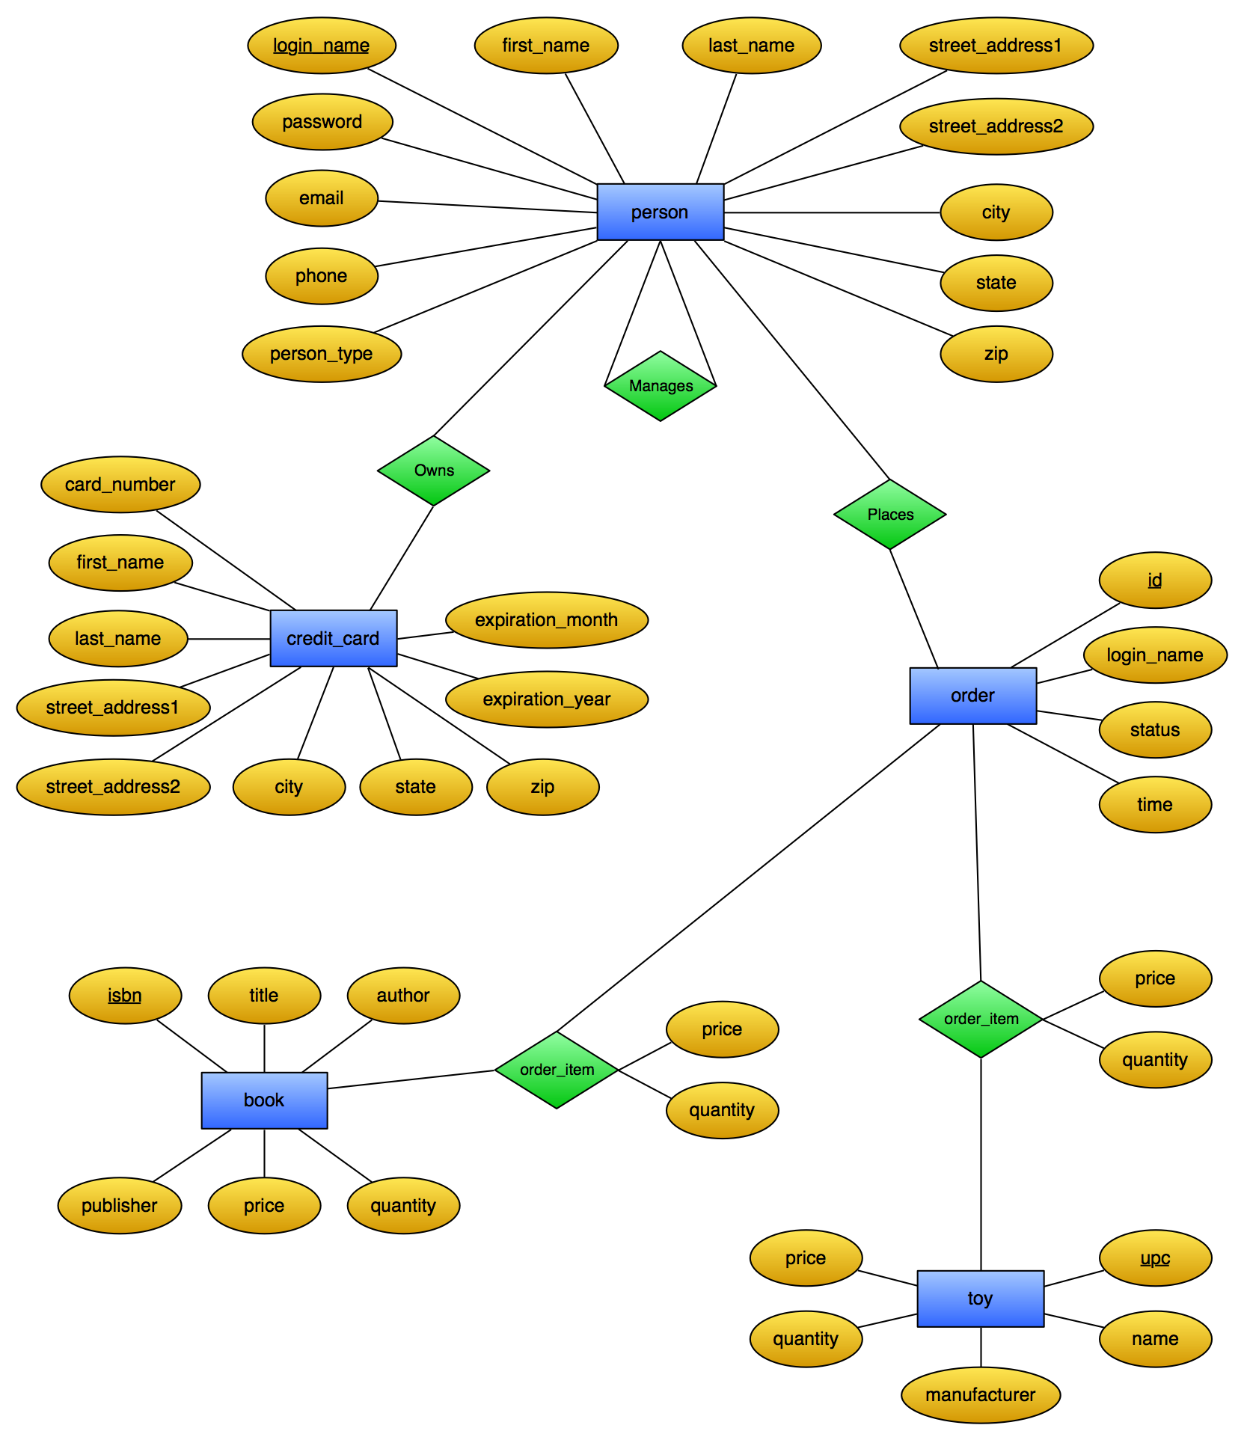
Figure 1 - Entity-Relation Diagram

Discussion
An examination of the diagram reveals that that the database models people, credit cards, books, toys, and orders at entities and uses the owns, manages, places, and order item as relations that connect these entities. A few details of the diagram are of particular interest, as their meaning might not be entirely obvious.

People Entity
A single people table is used to store account information for customers, staff, and managers. The person_type attribute is used to distinguish them.

Credit_Card Entity and Owns Relation
While most entities and relations directly represent tables that are present in the database, the owns relation and the credit_card entity do not. The database is structured such that two people can have individual accounts and both own (physically) the same credit card. To achieve this, the credit_card entity stores its associated user’s login_name as well as its number as part of its composite key. The owns relation simply helps visualize this relationship. See Credit_Cards Table below for further information.

Price Attribute of Order_Item Relation
The order_item relation has two attributes: quantity and price. Since both toys and books contain a price attribute, the price attribute of order_items might seem redundant. However, a manager can change the price of an item, and the original sale price of an item contained in an order must be preserved, and this attribute allows the sale price to be recorded.

Cart
It is also important to note that the diagram makes no mention of the customer’s cart, as mentioned in the statement overview and the program specifications. A person’s cart is stored by the server in the data related to the person’s session, and does not appear in the database until the order is placed.

Tables and Fields
This section presents all of the tables that exist in the database. Each section provides a brief description of the table, a diagram of the table, a description of the column names, and a list of the functional dependencies present. The diagram illustrates the column names, key(s), and functional dependencies of the table. The database satisfies all requirements for the third normal form (3NF). See the section titled Normal Form of the Database below for a justification of this claim. Note that all table columns discussed below have the ‘NOT NULL’ constraint unless otherwise noted.

Orders Table
The orders table is used to keep track of orders placed and information related to the order. The items in the order will be stored in a separate table to meet the requirements of higher normal forms.

Diagram
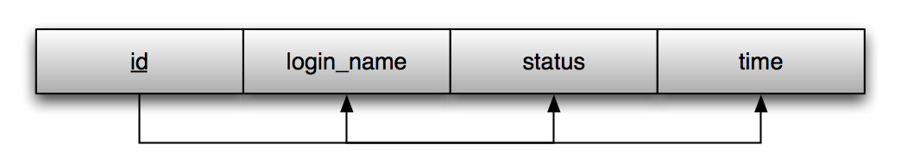
Figure 2 - Orders Table

Column Descriptions
- id (integer) – primary key
- login_name (varchar) – connects to customers
- status (enum) – order status
- date (datetime) – time of order placement

Functional Dependencies
- id → {login_name, status, time}

Order_Items Table
The order_items table is required to store the items, since one order can contain multiple items. Retrieving the entire order requires joining the orders table with the order_items table on id (orders table) and order_id (order_items table).

Diagram
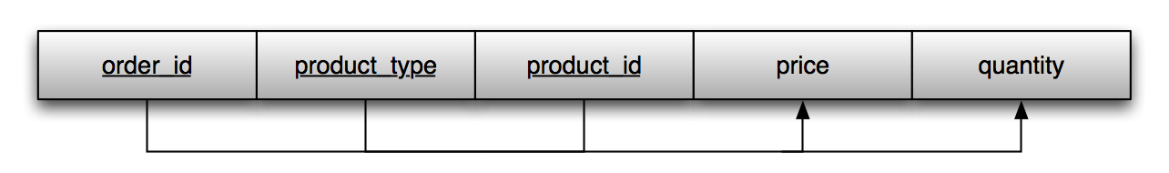
Figure 3- Order_Items Table

Column Descriptions
- order_id (integer) – connects to orders table
- product_type (enum) – enum type with choices 'book' and 'toy'
- product_id (varchar) – connects to either toys or books, depending on product_type. This is an ISBN number for a book or a UPC number for a toy.
- price (float) – this needs to be replicated here in case the product price changes after the customer placed their order. The price field in the books and toys table will reflect the product's current price, and having it replicated here allows Nile to change the price without upsetting their customers by promising one price but requiring another.
- quantity – how many of the item were ordered

Functional Dependencies
- {order_id, product_type, product_id} → {price, quantity}

People Table
The people table stores data about individual people (customers, staff, and managers). The address stored here is the person's shipping address.

Diagram
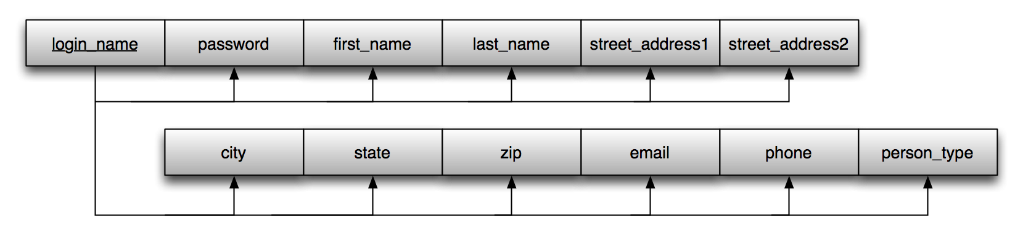
Figure 4 - People Table

Column Descriptions
- login_name (varchar) – primary key
- password (varchar) – encrypted password to increase security
- first_name (varchar) – person’s first name
- last_name (varchar) – person’s last name
- street_address1 (varchar) – first line of person’s street address
- street_address2 (varchar, may be NULL) – second line of person’s street address
- city (varchar) – city
- state (char, 2 characters) – state postal code
- zip (varchar) – zip code
- email (varchar) – store in case person needs to be contacted
- phone (varchar, may be NULL) – secondary contact method
- person_type (enum) – identifies the person as a customer, staff, or a manager

Functional Dependencies
- login_name → {password, first_name, last_name, street_address1, street_address2, city, state, zip, email, phone, person_type}

Books Table
The books table stores information about the books offered at Nile.

Diagram
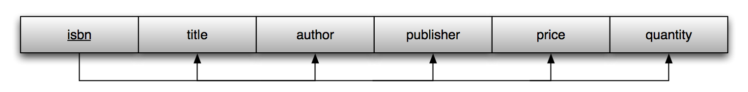
Figure 5 - Books Table

Column Descriptions
- isbn (string, since an ISBN number is so long, it might be too big to reasonably store in an integer field) – primary key
- title (varchar) – book title
- author (varchar) – author’s name
- publisher (varchar) – publisher’s name
- price (float) – current price for this book
- quantity (integer) – number in stock

Functional Dependencies
- isbn → {title, author, publisher, price, quantity}

Toys Table
The toys table stores information about the toys offered at Nile.

Diagram
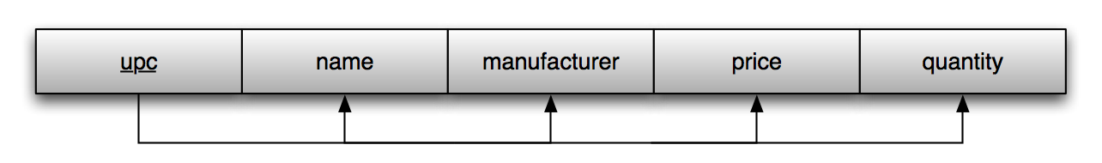
Figure 6 - Toys Table

Column Descriptions
- upc (char, 12 characters) – universal product code, primary key
- name (varchar) – product name
- manufacturer (varchar) – brand name
- price (float) – current price
- quantity (integer) – number in stock

Functional Dependencies
- upc → {name, manufacturer, price, quantity}

Credit_Cards Table
The credit_cards table stores credit card information. The address stored here will be the customer's billing address. The database is structured such that two people can own the same credit card. To ensure that each person has a credit card record dedicated solely to their account (they cannot change each other’s information or delete the other person’s card), the credit_cards table has a composite key composed of the user’s login_name and the credit card number.

Diagram
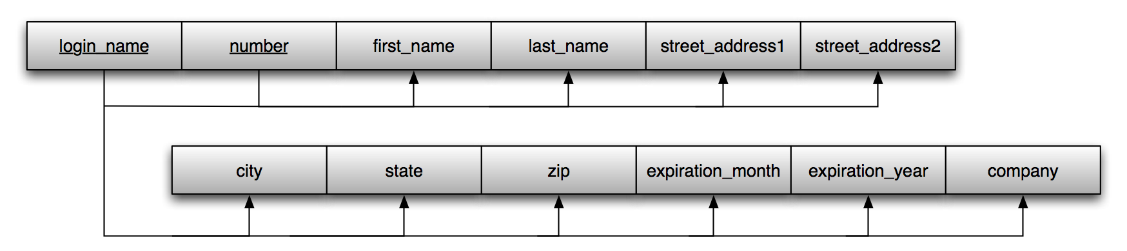
Figure 7 - Credit_Cards Table

Column Descriptions
- login_name (varchar) – person’s login name, connects to people table, part of composite key
- number (char, 16 characters) – credit card number, part of composite key
- first_name (varchar) – cardholder’s first name
- last_name (varchar) – cardholder’s last name
- street_address1 (varchar) – first line of credit card billing address
- street_address2 (varchar, may be NULL) – second line of credit card billing address
- city (varchar) – city of credit card billing address
- state (char, 2 characters) – state postal code of billing address
- zip (varchar) – zip code of billing address
- company (varchar)
- expiration_month (integer)
- expiration_year (integer)

Functional Dependencies
- {login_name, number} → {first_name, last_name, street_address1, street_address2, city, state, zip, expiration_month, expiration_year, company}

Normal Form of the Database
The group designed the database to meet the requirements of the third normal form (3NF), and the finished database meets these requirements. A justification follows in the sections below.

First Normal Form

Definition
The requirement of the first normal form given in the class text is “the domain of an attribute in a tuple must include only atomic (simple, indivisible) values and [the] value of any attribute in a tuple must be a single value from the domain of that attribute.”

Discussion
Two design decisions were made based on this requirement.

First, the order_items table was created to ensure that all attributes related to orders were atomic. A failure to meet this requirement would arise if one attribute of the orders table contained multiple items. Hence, each item is stored in one row of the order_items table.

Secondly, each person could have multiple credit cards. Rather than store them collectively in the people table, each credit card for each person is given a row in the credit_cards table.

The database therefore satisfies 1NF requirements.

Second Normal Form

Definition
The definition of the second normal form given in the class text is “A relation schema R is in 2NF if every nonprime attribute A in R is fully functionally dependent on the primary key of R.” This means that every attribute that is not part of the key is functionally dependent on the entire primary key – not just part of it.

Discussion
The only tables affected by this requirement are credit_cards and order_items, since they are the only tables with composite keys.

The credit_cards table meets this requirement, since it requires both the user’s login_name and the credit card number to uniquely identify a record. Each user can enter whatever other information they wish, thereby creating a full functional dependency of every non-key attribute on the entire key.

The order_items table also meets this requirement, since it price and quantity refer to a specific type of product with a specific id on a specific order. The absence of any of the three components of the composite key would result in the inability to know the price and quantity. This means that all of the nonprime attributes are fully functionally dependent on the entire key.

The database therefore satisfies 2NF requirements.

Third Normal Form

Definition
The definition of the third normal form given in the class text is “a relation schema R is in 3NF if it satisfies 2NF and no nonprime attribute of R is transitively dependent on the primary key.”

Discussion
All functional dependencies in the database are of the form:

{simple or entire composite primary key} → {nonkey attribute(s)}

This is clearly visible by inspecting the figures in the section titled Tables and Fields above. These functional dependencies are listed under the Functional Dependencies section for each table. The database therefore satisfies 3NF requirements.

Programming

Database Interface
The database interface was written in Ruby, and is structured such that a single class is dedicated to interacting with each table. Database queries are performed using the MySql class, which is included in a standard Ruby distribution. A Connector module was written to create a default MySql object (a connection to our database) and allow operations (queries) on that object.

Diagram
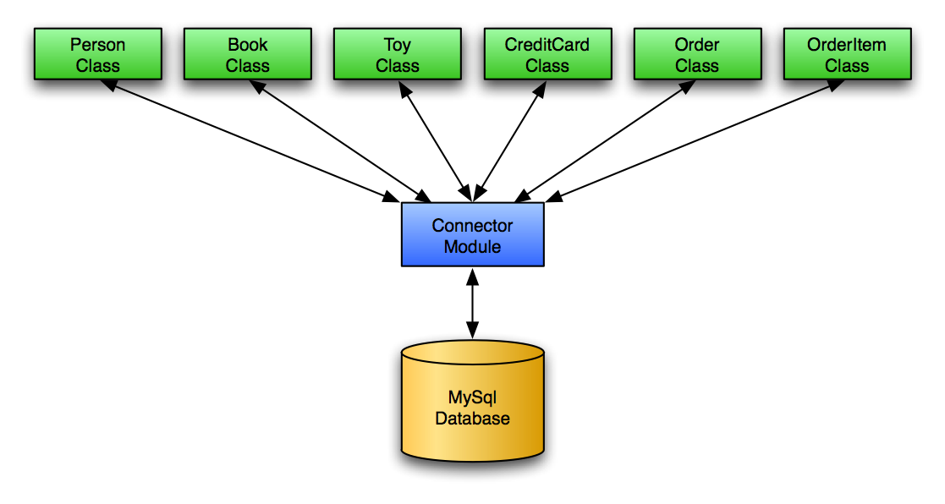
Figure 8 - Database Interface

Database Table Classes
As mentioned above, a class was written to interface with each database table.
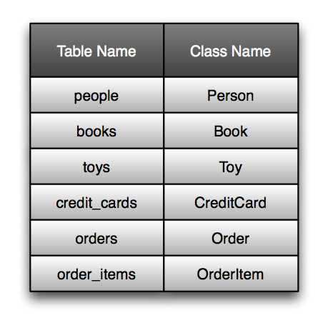
Table 1 - Database Tables and Class Names
Each class provides the standard methods described below in addition to specialized functionality. While other methods exist, these methods constitute the backbone of the database interface.

ClassName.new( args={} )
This method creates a new object of the class from a hash of symbols and their values, each pair corresponding to an instance variable for the resulting object. The object returned does not necessarily exist in the database. An exception is raised if mandatory symbols are not included in the hash.

ClassName.find( primary_key )
This method attempts to find a record in the database’s table corresponding to this class with the given primary key. If it is found, an object of this class is returned whose instance variables match the values of the database record. If it is not found, nil is returned.

ClassName.create( args={} )
This method attempts to create a database record in this class’s table from the hash provided. An object of this class is created using ClassName.new( args ). If this succeeds and no record in the table with the provided primary key exists, the database entry is created. If unsuccessful, the Connector module raises an exception. This new object is returned in either case so that the cgi script may take an appropriate action.

ClassName.delete( primary_key )
This method attempts to delete a database entry from this class’s table with the given primary key.

InstanceName.update( args={} )
This method attempts to update the database entry corresponding to this object from a hash of symbol names and their corresponding values. An exception is raised if the update fails.

Security Concerns

SQL Injection
The database interface protects against SQL injection, intentional or otherwise. It achieves this through a method that was added to Ruby’s String class for this project called contains_sql?. When this method is invoked on an instance of the String class, the string is compared to an array of regular expressions (Regexp objects). Each of these objects contains either a MySQL keyword or special character that could interfere with the intended operation of the database. If a string that would be inserted into a database query contains a forbidden substring, an appropriate action is taken – often an exception is raised. See Password Encryption below for how SQL statements in passwords are handled.

Password Encryption

Overview
All passwords are encrypted before they are stored in the database using Ruby’s built-in String#crypt method. This method was selected to encrypt the passwords for two reasons. First, it was readily available as part of the Ruby language. Second, and more importantly, the method uses a salt to encrypt the given string. This means that someone attempting to decrypt the string must know the encryption algorithm as well as the two-byte (16 bit) salt (key) used to encrypt the string.

Salt Generation
To increase the complexity of the password encryption method, each user’s password is given a personal password salt (2¹⁶ different possibilities). This salt is derived from the system time when their account is created, yielding a pseudorandom salt for each user. This salt can be found by examining the encrypted password, but since Ruby does not provide a String#decrypt method, this encryption is essentially a one-way encryption – the password can be encrypted, but not decrypted. To verify a password, the following steps are taken (see the Person#verify_password method):

- The user’s password salt is retrieved from their database entry (or the password instance variable of the Person object)
- The password to verify is encrypted with the user’s salt
- The encrypted passwords are compared

Password Encryption and SQL Injection
It is clear from the above discussion that a user’s actual password is never submitted to the database as part of a query. The user’s encrypted password gets stored in the database. This raises an interesting issue. A user’s encrypted password appears to be pseudorandom printable characters. It is therefore possible that this user’s encrypted password contains either an SQL keyword or special character. In fact, errors due to special characters were observed during testing using a very small data set. Therefore, when a user creates a new account and their password is encrypted with their newly generated salt, that password is checked for forbidden substrings. If any are found, a new salt is generated and the resulting password is checked for forbidden substrings. This process is repeated until a “clean” encrypted password is generated. Note that the password the user enters remains unchanged, since it is the salt that is changed until a suitable one is found.

Relevant Files
The following is a list of files related to the database interface and a brief explanation of their functions.

Primary Files
- config.rb – basic settings, configurations, declarations, and require statements
- connector.rb – provides clean interface to the MySQL database
- person.rb – interface to people table
- book.rb – interface to books table
- toy.rb – interface to toys table
- credit_card.rb – interface to credit_cards table
- order.rb – interface to orders table
- order_item.rb – interface to order_items table
- scaffold.rb – parent class for Person, Book, Toy, CreditCard, Order, and OrderItem classes – provides basic search capability and other features

Auxiliary Files
- string.rb – provides protection against SQL injection
- keyword_processor.rb – verifies that mandatory fields are provided when creating new objects
- symbol.rb – allows for dynamic creation of processes
- array.rb – defines Array methods to help in printing contents
- inflector.rb – allows for easy change of plurality of nouns
- inflections.rb - allows for easy change of plurality of nouns
- argument_contains_sql.rb – defines an exception class for SQL injection exceptions

Testing
This portion of the project was tested using irb (Interactive Ruby). irb is an interactive Ruby interpreter that is run from the command line. As each method for each class was developed, irb was invoked and sample code to test the method’s functionality was entered at the prompt. Testing in this manner allowed very specific tests to be conducted, since any method in question could be tested in an isolated manner. Functionality was easy to verify since irb echoed method return values to the console, and the result of successful operations could be clearly seen by performing manual database queries.

Every method of every class in the database interface was tested in this manner to verify proper operation.

Web Interface
The web interface will consist of a combination of XHTML, CSS, and possibly Javascript. The XHTML will be used to define the structure of the pages, the CSS will be used to adjust their appearance, and the possible Javascript usage would only be to improve the user's experience. However, were Javascript to be used, it would introduce no functionality that would be necessary for a customer to use Nile's site, because that would be too exclusive since Javascript is not supported/enabled in all browsers.

Valid XHTML and CSS, according to the World Wide Web Consortium's standards, will be used to help ensure that the site is viewable and navigable in as many browsers as possible. Attention will be paid as well to accessibility as described on these sites:

- http://www.w3.org/WAI/
- http://www.section508.gov/

Following such guidelines will help ensure that the site is accessible by all customers, regardless of any disabilities they may have or limitations they may face in terms of computer software, hardware, or Internet connection.

